**Content**

1. Nadpis 1 3

1. DNS Overview

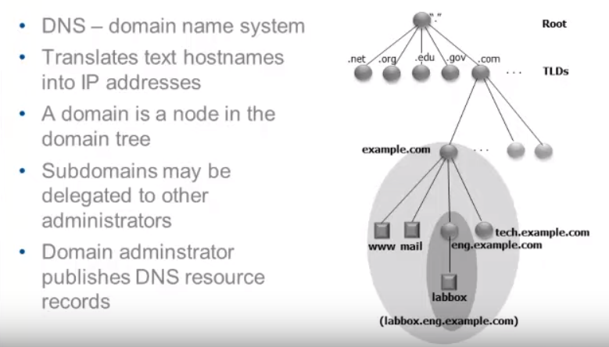

**DNS Resolver:** DNS resolvers play a key role in converting Web links to IP addresses, acting as a link between your computer and the Internet's DNS infrastructure. A DNS resolver is a local server that stores a central database of DNS nameservers and manages DNS requests for all the clients on your network. With DNS resolvers, your computer does not need to store addresses for multiple online nameservers, a process which is difficult to manage effectively.

